The following are the screenshots of the pages opened on running the application **“Lab6StudentManagement”** depicting the functionality of the various pages of the application.

The first page: **Login page**

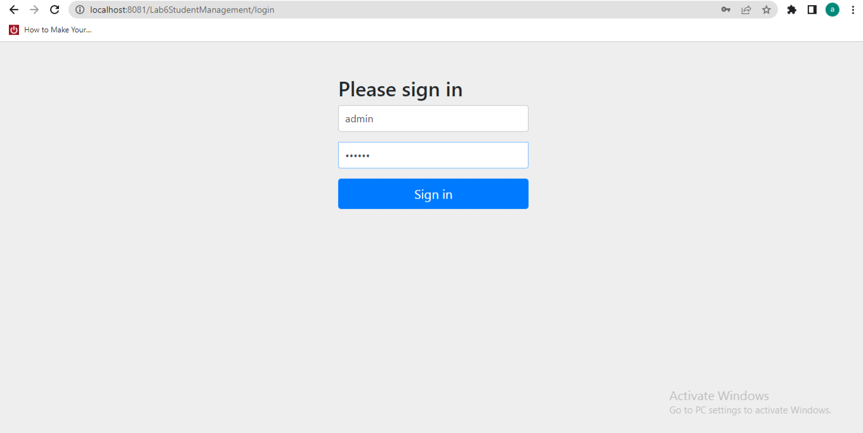

On successfully signing in as **“admin”** we see the first page listing the students in the table.

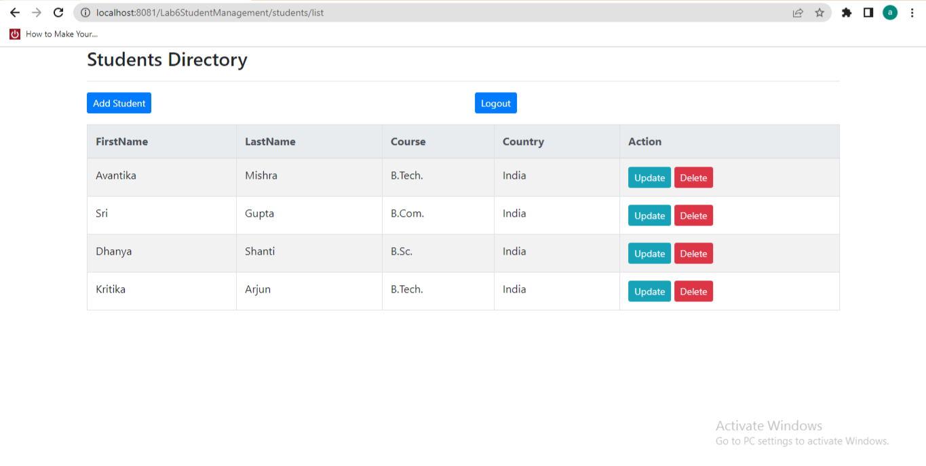

**Add The Student** “Ananda Geeta” As An Admin:

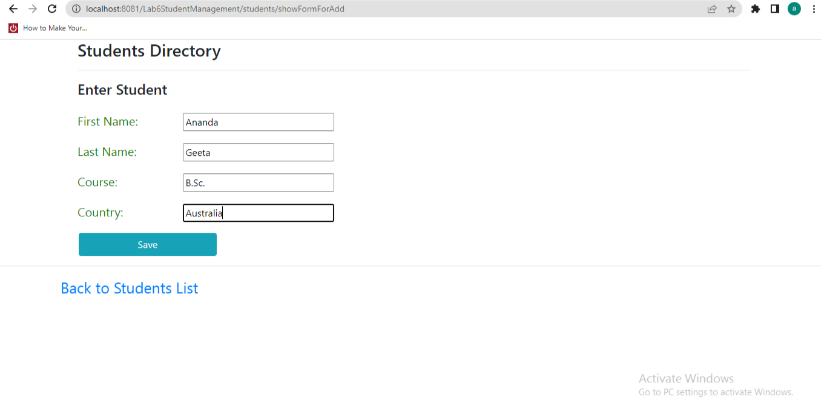

**The page opening up on successfully adding “**AnandaGeeta**” in the table.**

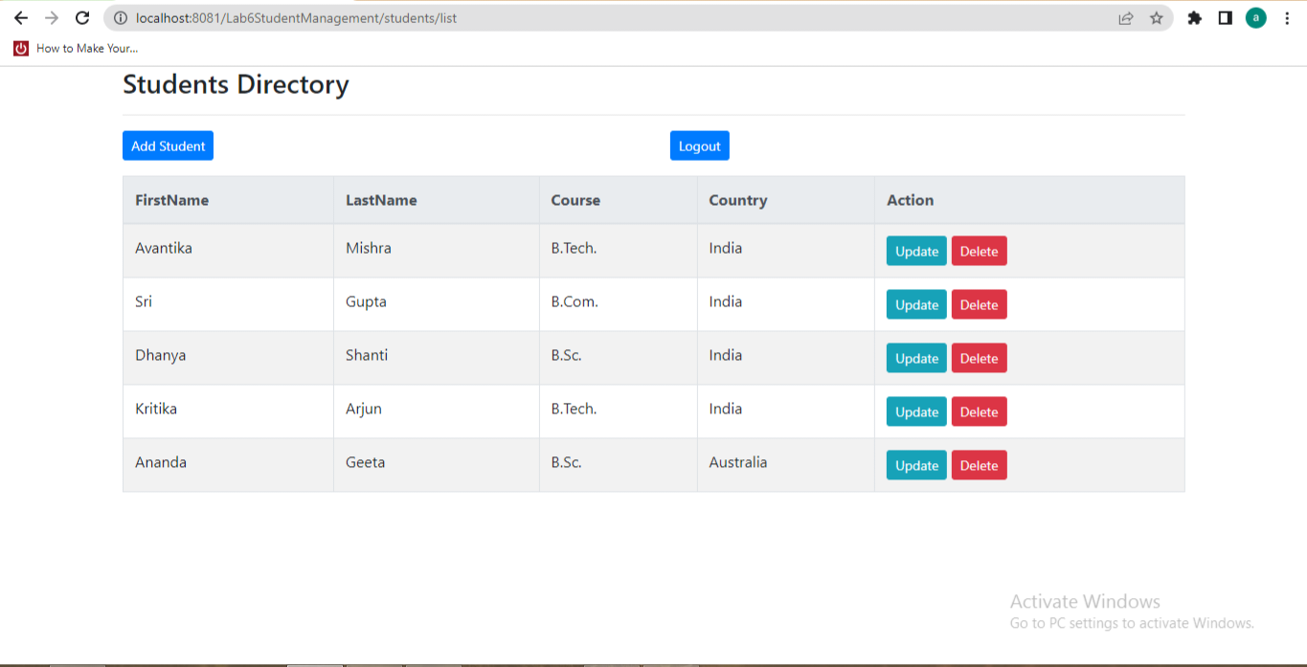

**To show the functionality of deletion (that is allowed only to the admin):**

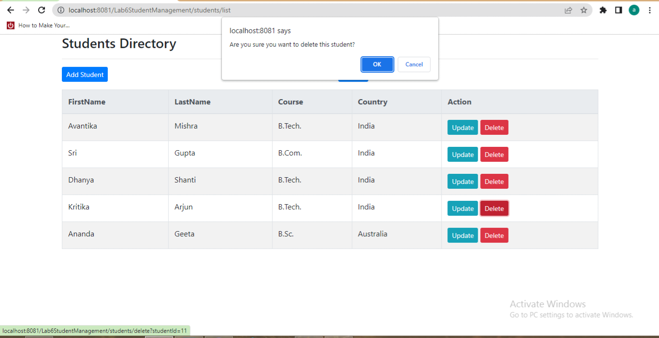

**The updated table after deleting “Kritika Arjun”:**

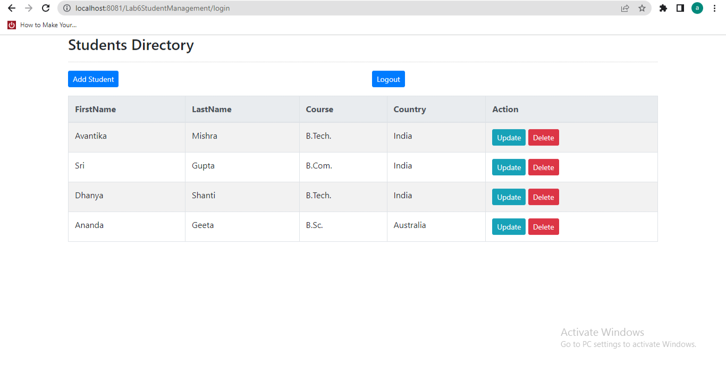

**The page on clicking the button “Logout”:**

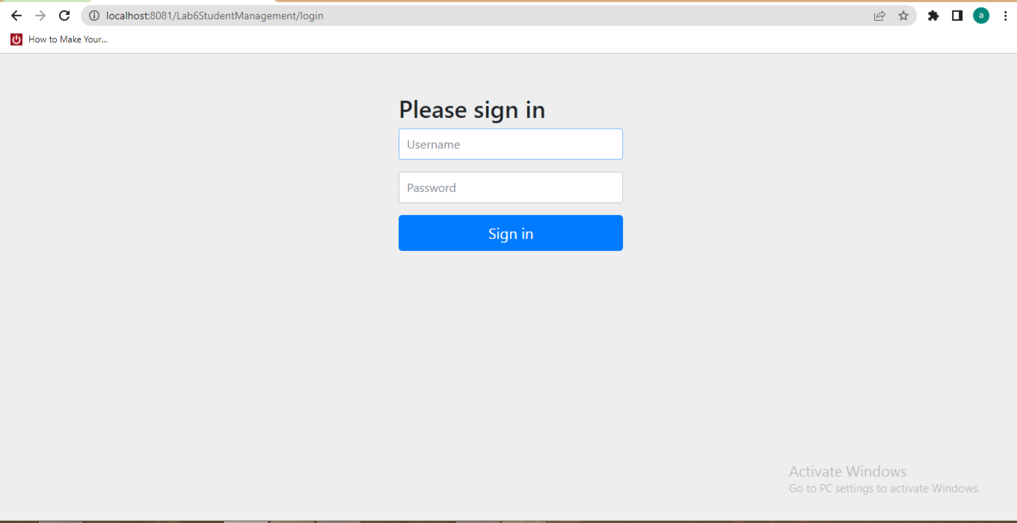

**USER FUNCTIONALITIES:**

**Now we will enter as a “user” in the system.**

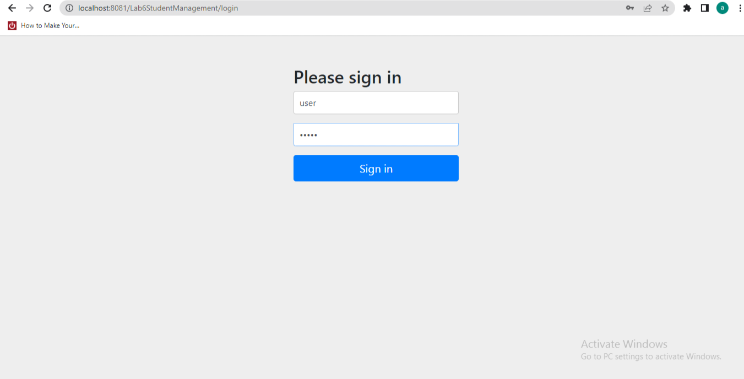

**The page that opens up on successfully entering the system as user is the page listing the students:**



**The page showing the functionality of adding the student “Shubham Rathore” to show that the user has the access to add a student in the database:**

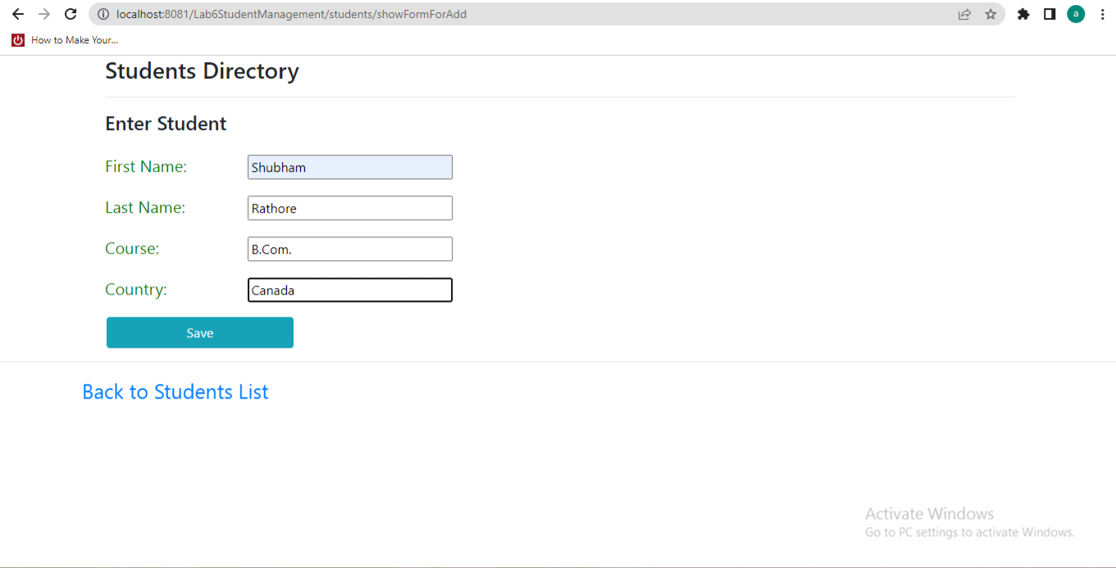

**The updated table after successfully adding a student:**

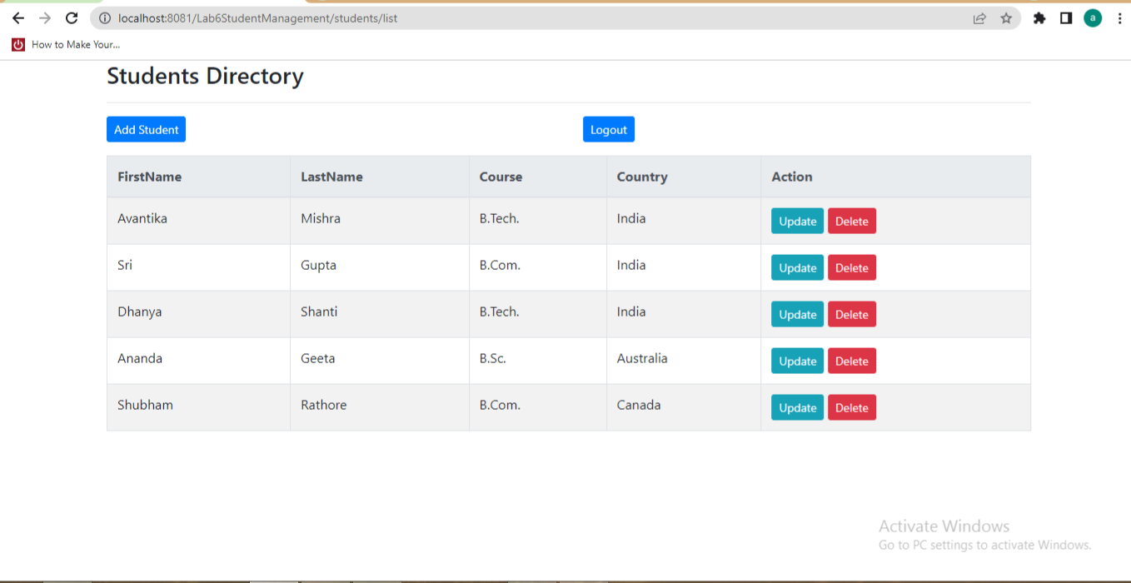

**Now we know that the user has the access of adding and viewing the table and not to update or delete, so the page that opens up on trying to update or delete a student is:**

**The following screenshot shows the error page opening on trying to update.**

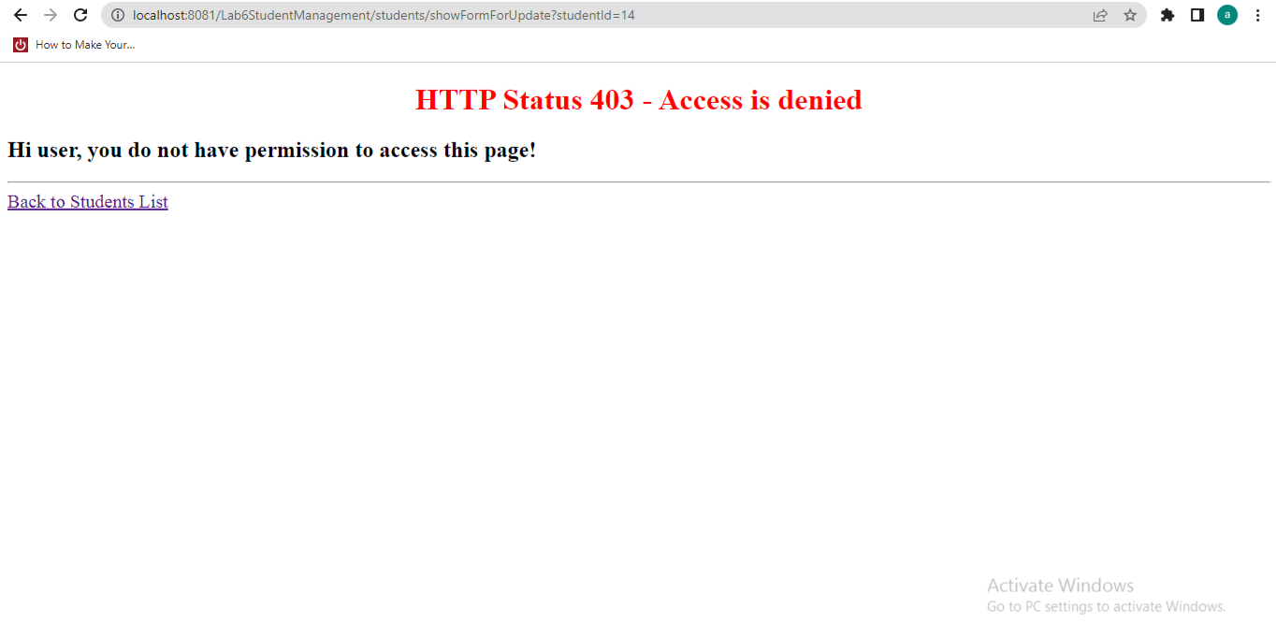

**The following screenshot shows the error page opening on trying to delete.**

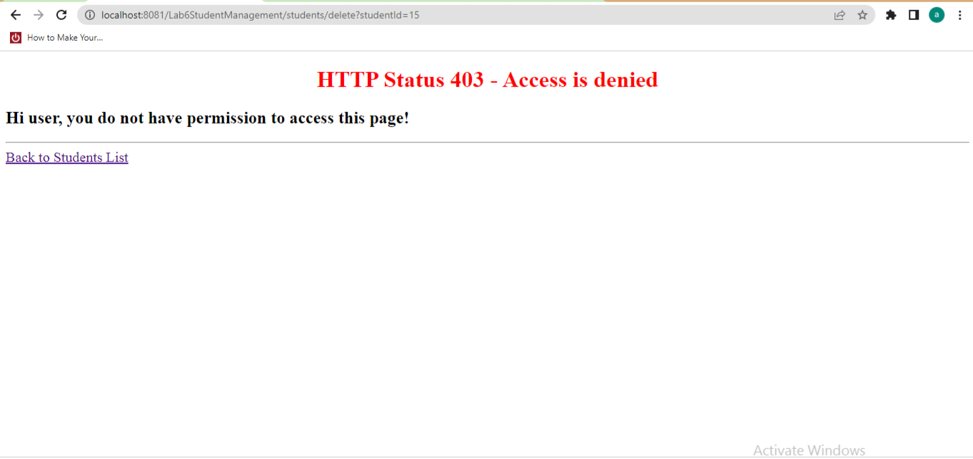

**On clicking on the back to students list on the error page, the user is directed back to the list page.**



**On Logging out the login page opens up.**



**FOR REFERENCE:**

**The following screenshots show the tables containing the details of the user, their roles and the table showing the mapping of the roles and the users.**

**TABLE 1:**

**The table showing the entries of the roles as “ADMIN” and the “USER”:**

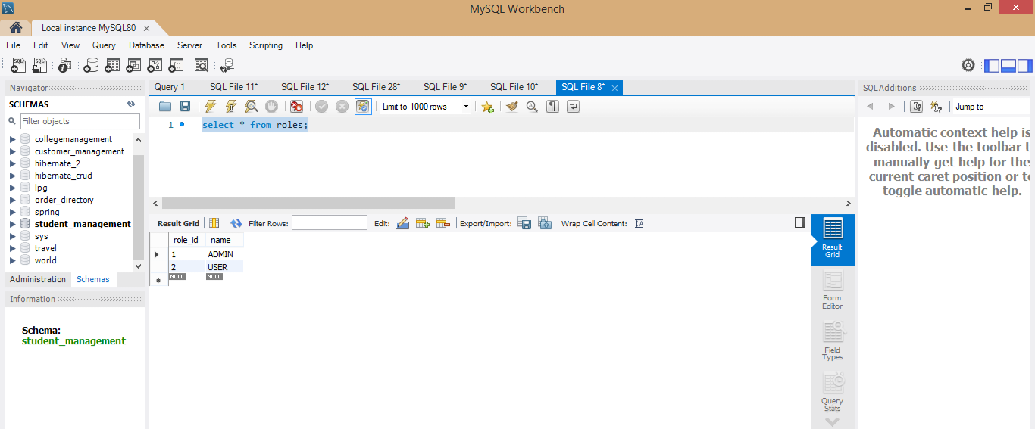

**TABLE 2:**

**The table showing the “users” with the entry of their username and password along with their** id’s**:**

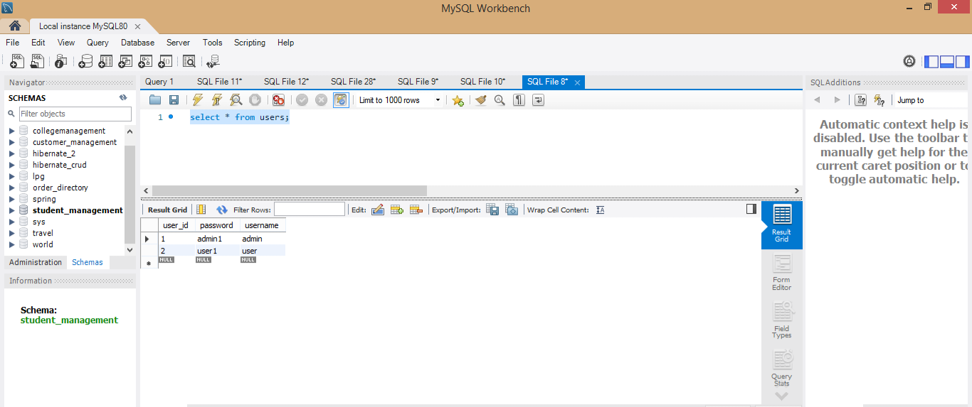

**TABLE 3:**

**The table “user_roles” that contains the user connected with the role through their respective** id’s**.**

